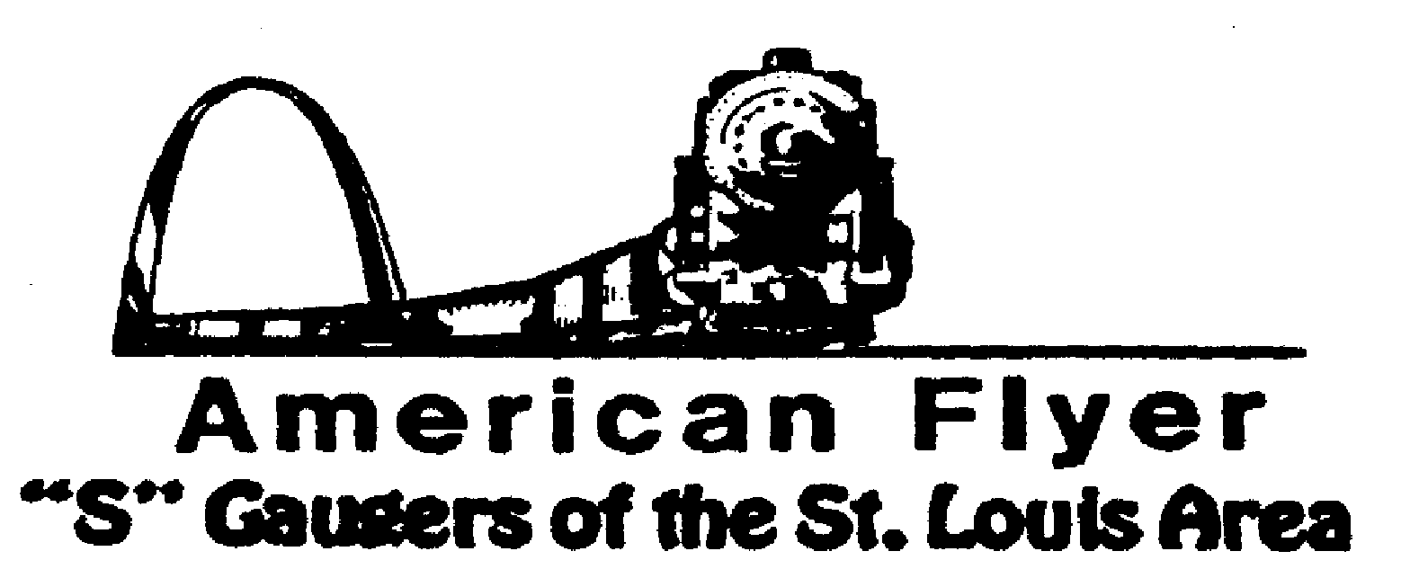

Website: www.trainweb.org/afsgsla/ E-Mail: afsgsla65@gmail.com
_____________________________________________________________________
AFSGSLA LETTER
October 2021

AFSGSLA Club Events and Related Activities:
Events are slowly starting to happen, here are some we know about.

As with the last several newsletters, we are combining the planned club events and the other related activities. Although we will not necessarily participate in some of the following events as a club, they are included in this somewhat comprehensive listing for your information. We suggest you keep this newsletter for your future reference and attend our club meetings for full details..

Actual Scheduled Events (obviously subject to change at the whim of some government official)

Saturday, October 9, 2001: Prior newsletter had incorrect date. Paul Voegtle offered to host an in-person Saturday meeting on October 9 at his farm in New Athens, Illinois. He would like for us to arrive at noon for lunch. The meeting will end at 3:00 pm. He plans for us to be outside and said that if rain is expected, we will move to a large shed. The address of his farm is 7326 Calmus Lake School Road. His phone number is 618-365-2636. His new email address is PJCRUSIN2@GMAIL.COM. Paul asks that you RSVP about a week ahead of time so he can plan the food.
Saturday and Sunday, October 2-3, 2021: Great Train Show, Belle Clair Fairgrounds, Belleville, IL. THIS SHOW HAS BEEN CANCELLED DUE TO COVID.
Saturday and Sunday, October 9 & 10, 2021: Mississippi Valley N Scalers (MVNS) show at the Kirkwood Community Center, Kirkwood MO. We WILL NOT be displaying our sectional layout this year due to Covid so dealer tables can be spaced out.
Friday – Sunday , November 5th thru 7th 2021 - The Badgerland S Gaugers have rescheduled the 45th Annual Fall S Fest for 2021. In 2020, the FSF was postponed until this year. Since we missed a year, I am not sure we can continue calling it annual, but you get the idea. The event will take place at the same location the Four Points Sheraton Airport Hotel. NEW INFO from Badgerland: Due to the Covid issue the Badgerland S Gaugers realize that there may be some hesitancy in signing up early for this year’s Fall S Fest. The cutoff date for the early registration discount has been extended to September 30th.
Saturday, November 13, 2021: Dupo Train Show, 9:30am until 2pm. Dupo American Legion Post, Dupo, IL. It is anticipated that we will display the double helix.
Saturday and Sunday, November 27-28, 2021: Great Train Show, Collinsville Convention center. No word yet on if we will be participating.
Saturday, December 4, 2021: TCA train Show at Lutheran church in Olivette MO. 9am-3pm. It is anticipated that we will display the double helix, but anything this far out will need to be verified.
Tuesday, December 7, 2021: John Nosari Open House John is planning an open house like he did 2 years ago. It will be on Tuesday Dec 7 th from noon to 5. Lunch will be served with his usual Italian Roast Beef and other fixings . All members and their spouses are invited that have been vaccinated for COVID. Any questions let him know. He says he has made significant progress on his AF layout. His house is off of exit 83, Glenarm. About 70 minutes from I 70 and I 270 or 90’minutes from the Arch

Formerly Scheduled Events that are now Cancelled

What’s been happening?

September 10, 2021: AFSGSLA club meeting hosted by Cliff and Gail Saxton. The first in person one since the pandemic. It was enjoyed by all that attended.

AFSGSLA’s Club Order of Special Cars:
As always, if you are interested in participating in these club orders, it would be to your advantage to attend the club meetings where details are made available and arrangements are finalized.
---The status of the Special Cars previously ordered have all been delivered.

2020 SFest Cars - There will be two different Milwaukee Road (what else being in Milwaukee) 2 Bay Offset Hoppers with black coal loads. The cars are $55.00 each (plus the registration fee of $18.00) if picked up at the S FEST. These will now be the 2021 SFest cars. NOTE: Badgerland S Gaugers has these cars in stock, so you will not have to wait months, or years, for them.
2021 TCA Convention cars - TCA has announced their 2021 Convention Cars, and they include an American Flyer S Gauge F.H. Hogue Melons Woodside Reefer, a Bald Eagle Grapes Woodside Reefer and a Yosemite Oranges Woodside Reefer. They are very nicely done cars. The club order has been placed. Dave Stone will be notifying the club members who bought cars, when they arrive. They are being shipped to Dave’s home.

This and That

St. Louis Lionel Railroad Club – Things can change very suddenly. After being told the building was not going to be sold, it was. The club has to vacate by the end of October. Work is currently underway to put things in a storage locker until a new location can be found. More as it becomes available.
Craig Tarpoff - Craig Tarpoff (618-451-0729, ctarpoff@gmail.com) has informed us that he wants to sell the original DH which has resided in his train room in Granite City for over 20 years. Craig was also the designer/builder of the club DH (with the help of some members). He has been spending his winters in Hawaii, but as he has sold his restaurant wants to participate in club events when he is available.

Note from Vince Love – Vince has asked me to inform club members that he has all the pictures he took at the last several FSF and they are available. Contact Vince for specific information. It was discussed about putting them in the newsletter, however since some copies are mailed, it would make it too long.

Midwest Money Layout Open House - Sponsored by the Midwest Money Company, on the First Sunday of every month from 11:00 A.M.to 4: P.M. They are located at 5901 Hampton, St. Louis MO just across Holly Hills Street. The layout is rather large, fully developed scenery 3 rail O-Scale layout. This rather large layout may be one of only a very few which can be claimed to be 100% complete. This location is in South St. Louis City, roughly hallfway between Chippewa and Gravois

Special notice from David Stevens: Dave has had it easy recently, but as you can see, we are hoping to get back to in person club meetings now 2021. We have had a number of our faithful club members who have volunteered to host future meetings. Although our David Stevens is especially pleased with the excellent response to his recent requests, he tells us that we still need club members to volunteer to host club meeting in the future. He states that if you have not hosted a meeting recently---or ever---please carefully consider doing so. It is a great way to “pay your dues” and it really is not much trouble to host a club meeting (the club pays our host a modest fee to offset expenses for refreshments). We have often said (and our hosts have agreed) that there is no surer way of getting your train room shaped up then hosting a club meeting. David Stevens will help you with the details, if you just contact him at Telephone: 314/ 921-1127 or stevens8128@sbcglobal.net.

Notes from your Co-Coordinators!

TOM SCHNUR
AFSGSLA Co-Coordinator
afsgsla65@gmail.com

RICK ARCHESKI
AFSGSLA Co-Coordinator
rcheski@charter.net

That’s it for now, more later:
GARY MUELLER
AFSGSLA Newsletter Editor
gmatmueller@aol.com

-And remember, “It’s just for the fun of it!”

